Create a PO
PO: 500000665164
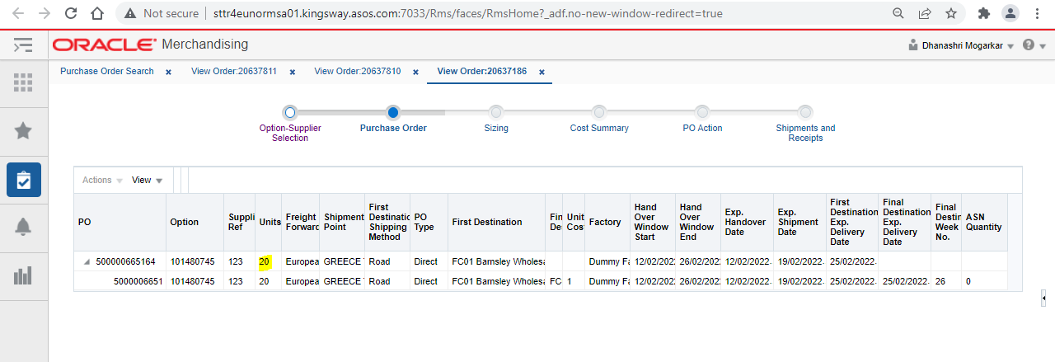
Process it SO file through Putty with the mismatch in units as you can see the highlighted units in below screenshot
You can check the details of SO file in database as below
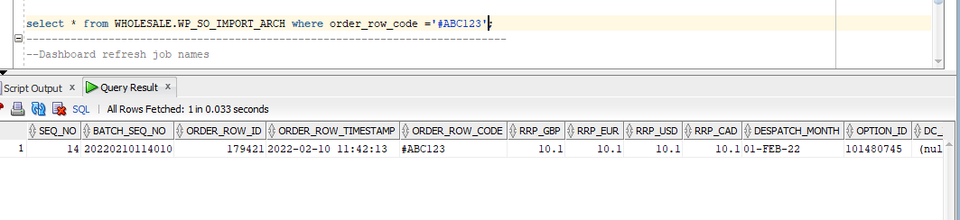
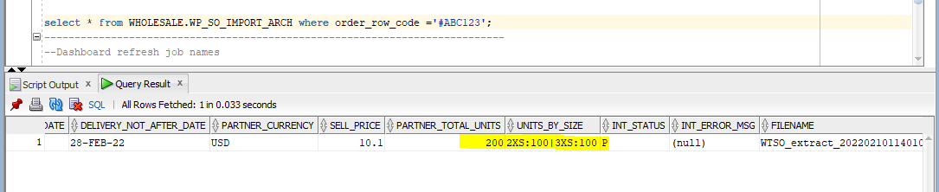

Now refresh the dashboard by running a Putty command and you will be able to see that record in pre unit receipt variance dashboard as follows under green color
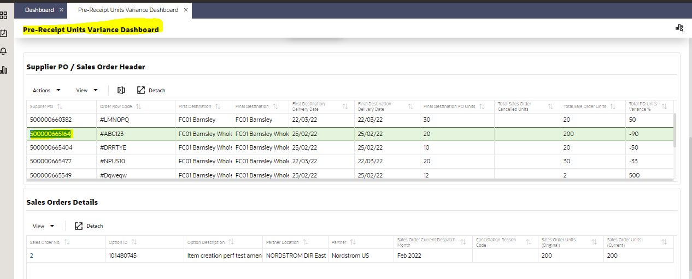

Red Colour Tile
If you want your data to reflect in red colour, you need to perform FC/carrier booking on that data as below
Create ASN of PO: 500000665484 by using ASOS NET portal
URL: http://sttr4eunsupla01.kingsway.asos.com:7033/SupplierCollabViewControllerASOS/faces/Home?_adf.no-new-window-redirect=true
Note: Make sure that your item is gold sealed
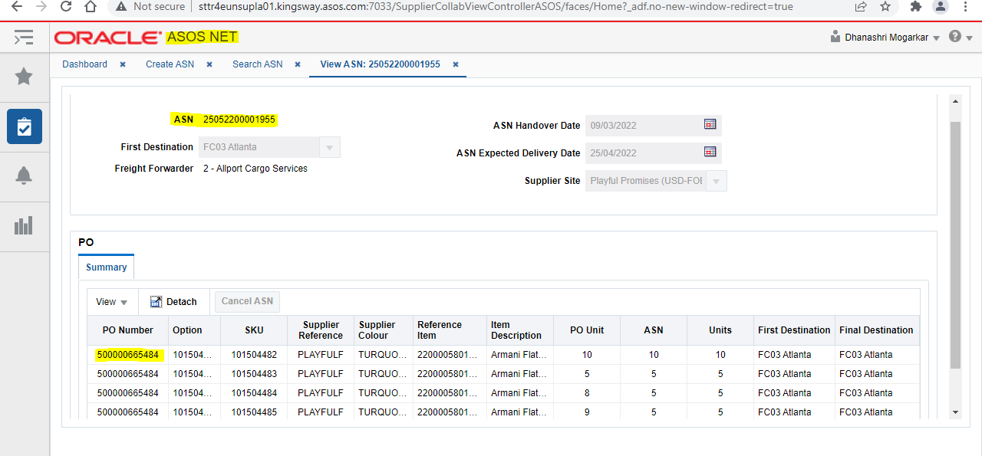

Run a query through Database to make it FC/Career booking to your PO
Update rms.NB_SHIPMENT_CFA_EXT set date_24 = to_date ('22-DEC-2020', 'DD-MON-YY') ,date_25= null
where shipment = ( select shipment from rms.Shipment where asn = '25052200001955');
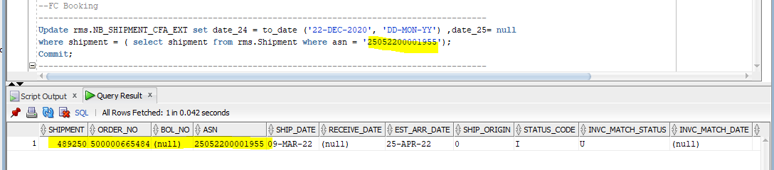
Now refresh the dashboard by running a Putty command and you will be able to see that record in pre unit receipt variance dashboard as follows
